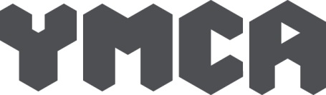
Job Profile Maintenance Worker
Reporting to | Senior Maintenance Manager | Job Level:
Service Area | Housing services | - Entry level/Ancillary  - Service Delivery  - First Line Manager/Qualified Practitioner/ Specialist  - Manager/Clinical Supervisor/Senior Specialist  - Senior Operational Management  - Strategic Leadership
Location | West Sussex
Contract | Permanent

Where you fit

Job purpose

The postholder will be expected to contribute to the provision of high quality, safe, welcoming and secure supported housing.

To provide responsive decorating, caretaking and maintenance services, mobile working across local sites managed by YMCA DownsLink Group, including conducting and monitoring recurring regulatory and compliance activities on buildings. To oversee external contractors and organise joint working between YMCA staff.

About us
We help children and young people have a fair chance to be who they want to be. We do this by providing a safe home, increasing life skills and self-confidence, and improving emotional wellbeing and mental health. Each year, we support thousands of children and young people up to the age of 25 across Sussex and Surrey. We offer support in three service areas:
• Housing provision and sustaining accommodation
• Specialist information, advice and support
• Emotional wellbeing and mental health

We are a member of the YMCA Federation of England & Wales and are guided by their vision of ‘transforming communities, so all young people can belong, contribute and thrive’. This vision reflects the original Christian foundation of the YMCA movement, but with a clear emphasis on being an inclusive organisation.

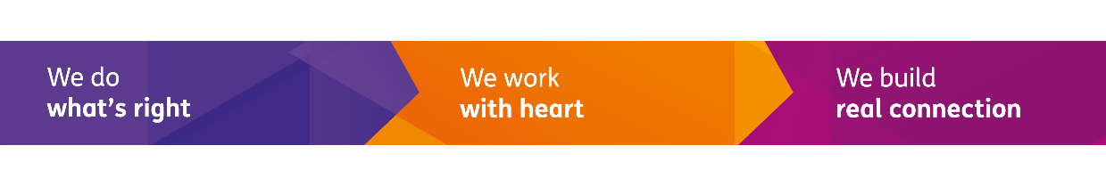

Responsibilities
- To carry out day-to-day maintenance at the allocated sites.
- To oversee compliance testing process, carrying out and/or organising regulatory and compliance inspections at sites across locality
- To carry out maintenance/repair work or redecoration as required and notified by staff, line management or the Project Manager, including carpentry and plumbing.
- Perform common household tasks to maintain a clean workplace. This may come in the form of sweeping floors and dusting; cleaning walls, toilets and windows; litter-picking and removing rubbish from bins.
- To carry out void repair work, including clearances and storage/disposal of bulky/electrical items, and keep within the YMCA’s agreed Key Performance Indicators.
- Assess the cleanliness and hygiene situation of the establishment and detect current and potential problems.
- To Record and monitor work/jobs on YMCA Facilities Maintenance system (training will be provided)
- To prioritise the workload according to impact on the service and young people, managing and keeping records of own time using YMCA calendar and Facilities Management systems.
- To liaise promptly with Line Manager and local staff when the work required falls outside of capability or time constraints.
- To efficiently manage stocks of cleaning equipment and materials and order materials through our designated suppliers ensuring there is a constant supply.
- To promptly highlight any health and safety concerns resulting from maintenance issues to the respective local Manager, H&S Manager, and Line manager.
- To be part of and contribute to the YMCA DownsLink staff team, attending meetings as appropriate and keeping relevant staff appraised of work issues.
- To be involved in facilitating appropriate staff development and training.
- To attend appropriate continuing professional development and training events and be committed to team events.
- From time to time to assist in overseeing workflow at our facilities, organising day to day tasks for the maintenance staff within the locality, including supervision of apprentice(s) as appropriate.
- To carry out from time to time any other appropriate duties as directed by the Line Manager to support and promote the work of YMCA DownsLink in accordance with the post holders capabilities.
- The post holder will be expected to work across local YMCA sites and to manage their time and workload effectively, prioritising tasks.
- In liaison with the relevant managers (at the relevant sites) they can decide on the instruction of contractors and oversee the standard of work that will be expected.
- To understand and adhere to the COSHH and other H&S regulations.
- To refer to the relevant managers over the entry and access to rooms and the changing requirements of cleaning needs in the project.
- They must be sufficiently physically fit to be able to carry out the demands of the role, including occasional working at height, heavy lifting, and regular driving.
- To uphold and carry out the duties with due regard to the ethos and values of YMCA DownsLink including our commitment to equality and diversity, and the nature of its activities. As well as fostering a commitment to improving the lives of young people.
- To maintain expert professional knowledge and demonstrate ways of putting this into practice in the workplace.
General
- Work to our vision, mission and values
- Be committed to continuing professional development and utilise Reflective Practice Supervision as part of leading Psychologically Informed practice
- Comply with our policies and guidelines on safeguarding, health & safety, data protection and equity, diversity and inclusion, attend mandatory training, and abide by our Code of Conduct
- Carry out any other duties as may reasonably be required by YMCA DownsLink Group, including deputising as appropriate in areas relevant to own responsibilities
- Work in a team to work flexibly to ensure cover and to take responsibility for safe delivery during periods of lone working

Person Specification

Knowledge and experience
- A strong team player who can support and challenge colleagues appropriately
- Proven ability to provide a good quality decorating and maintenance service
- Experience of maintenance provision within a supported housing project or similar scheme
- Experience of caretaking/cleaning/decorating in a community setting
- Experience of keeping records
- Experience of compliance testing
- Previous work with young people is advantageous
- Knowledge of and commitment to safeguarding children and young people
- Familiarity with Health and Safety in the workplace
- An understanding of and an ability to adhere to professional boundaries
- Understanding of the issues faced by vulnerable young people and the impact this has on behaviour

Skills and abilities
- Flexibility and ability to adapt work schedule to meet the needs of urgent work, whilst ensuring lower priority work is kept up to date
- Solid standard of maintenance skills (e.g., decorating, carpentry, plumbing, tiling)
- Good organisation skills in order to prioritise workload
- Good communication skills both verbal and interpersonal
- Ability to deal with sometimes challenging behavioural situations
- Enthusiasm and genuine desire to help support the young people we work with
- Computer Literate (Word, Excel, Outlook)
- Ability to act on own initiative, dealing with unexpected problems that arise
- To manage time effectively to ensure that tasks are completed
- Full valid UK driving licence and ability to travel between sites

Qualifications and Training
- City and Guilds or equivalent in one or more maintenance skill areas desirable
- Manual handling Training desirable
- Handling bodily fluids Training desirable
- Boundaries Training desirable
- First Aid Training desirable

Employee Declaration
I confirm that I have read, understood and agree to the expectations of the role as outlined in this job profile:
Name: Signed: Date:

