Job Profile Data and Systems Support Officer
Reporting to | Digital Systems Project Manager | Job Level:
Service Area | Improvement and Impact Team, People and Programmes Department | Level 2 - Service Delivery
Location | Hove, East Sussex with ability to travel to other YMCA DLG locations across Sussex and Surrey
Contract | Permanent / 37 hours per week

Where you fit

Job purpose
This role provides hands-on support to the organisation’s data, reporting, and systems functions. Working closely with the Data & Performance Lead, you will take responsibility for regular reporting cycles, dashboard production, data quality checks, and provide back-up for first‑line administration of key systems including In‑Form (Salesforce), Pyramid, and other internal tools.

In this varied role you will deputise for the Data & Performance Lead, support training sessions, champion digital-first ways of working and use data to drive decision-making. You will also contribute to wider data-based projects. This is an ideal role for someone with strong attention to detail, an understanding of data, and a desire to learn analytics, system administration and digital tools in a supportive environment.

About us
YMCA DownsLink Group is the leading charity for children and young people across Sussex and Surrey. We offer safe homes, mental health support and trusted advice.

We believe that every child and young person has the right to be safe, heard and to shape their own future. We work alongside them to make that happen.

We are here for children and young people, many of whom face multiple challenges and need our support.

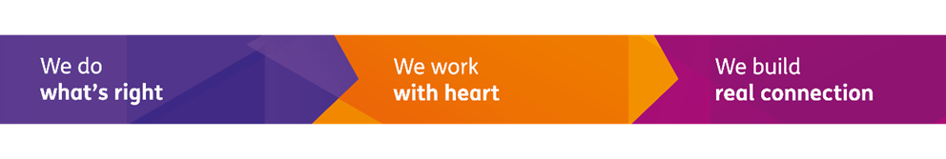
Our values - we do what’s right, we work with heart, and we build real connection – guide us in all our actions.

Responsibilities

Data Reporting and Insight Support
- Produce regular performance reports to agreed schedules (weekly, monthly, quarterly).
- Maintain and update dashboards in Power BI, Pyramid, and Salesforce (In Form).
- Conduct routine data quality checks and highlight anomalies or issues.
- Assist in preparing insight summaries for managers and service leads.
- Support ad hoc data requests by extracting, cleaning, and formatting datasets.

Dashboard Development
- Build and maintain user-friendly dashboards under guidance from the Data & Performance Lead.
- Implement version control, update logic, and optimise existing dashboards for efficiency.
- Support creation of automated reporting processes where possible.

System Administration
- Act as back-up first-line administrator for In-Form (Salesforce), supporting user accounts, permissions, page layouts, field updates, and basic configuration (training provided).
- Assist with testing system changes, upgrades, and new functionality - particularly for Pyramid and In Form system improvements planned for 2025/26.
- Log and track issues with external system providers or internal IT contacts.

User Support and Training
- Respond to queries about data entry, reporting, and system use. Assist in delivering induction training for new staff on data systems.
- Help maintain documentation, guides, and training materials.

General
- Work to our vision, mission and values
- Be committed to continuing professional development and utilise Reflective Practice Supervision as part of leading Psychologically Informed practice
- Comply with our policies and guidelines on safeguarding, health & safety, data protection and equity, diversity and inclusion, attend mandatory training, and abide by our Code of Conduct
- Carry out any other duties as may reasonably be required by YMCA DownsLink Group, including deputising as appropriate in areas relevant to own responsibilities
- Undertake any other duties aligned with the role’s scope.

Person Specification

Knowledge and experience
Essential
- Experience working with data in Excel or other tools (e.g., reporting, analysis, or administration).
- Basic understanding of databases or CRM systems.
- An interest in data, digital tools, analytics, or system support.

Desirable
- Experience with Power BI, Salesforce, Pyramid, or similar BI/CRM tools.
- Experience working in or volunteering within the charity, social care, youth, or housing sector.

Skills and abilities
- Strong attention to detail and accuracy.
- Ability to follow processes and manage time across competing deadlines.
- Good written and verbal communication skills, including explaining technical topics to non-technical colleagues.

- Strong digital literacy - Excel (lookups, pivot tables), Teams, SharePoint.
- Willingness to learn analytics, visualisation, and Case Management system admin.

Qualifications and Training
- No specific qualifications required - training and development provided.
- Beneficial: courses or certifications in Power BI, Excel, data analysis, or Salesforce admin.

Employee Declaration
I confirm that I have read, understood and agree to the expectations of the role as outlined in this job profile:
Name: Signed: Date:

