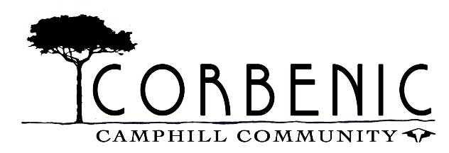

**Receptionist/General Administrator Job Description**

This job description outlines the key duties and responsibilities for the role. It does not form part of your contract of employment and may be subject to review and amendment in consultation with the post holder and line manager.

**Job Summary**

The Receptionist is the first point of contact for visitors, staff, and callers to Corbenic Camphill Community. The role involves delivering a professional and welcoming reception service, managing enquiries, and providing administrative support to ensure the smooth running of the office.

Key responsibilities include:

1. Reception duties – answering calls, responding to enquiries, and welcoming visitors.
2. Maintaining accurate electronic filing and archiving systems in compliance with GDPR.
3. General administrative tasks – including minute taking, ordering supplies, managing mail, and supporting office functions.

**Main Duties and Responsibilities**

**Reception & Communication**

* Answer and direct incoming telephone calls; take and distribute messages as appropriate.
* Provide a warm welcome to visitors and handle their enquiries.
* Ensure visitors sign in and follow appropriate policies.
* Handle incoming and outgoing mail.
* Respond to queries received by letter, email, or telephone, and refer to the appropriate staff member where necessary.
* Perform data entry tasks, ensuring accurate and timely input of information.

**Administration**

* Maintain and update electronic filing systems in line with GDPR requirements.
* Provide general office support including photocopying, scanning, shredding, and filing.
* Order office stationery and other materials as required.
* Liaise with IT/technology support providers when needed.
* Take minutes at management meetings (when required).
* Attend the weekly diary meeting and create the diary sheet.

**Communication & Media**

* Provide staff with general information and respond to routine queries.

**Other Duties**

* Undertake any other reasonable tasks as requested to support the efficient running of the office.

**Person Specification**

**Essential**

* Minimum 2 years’ experience in an administrative or clerical role.
* Proficiency in MS Office applications (Word, Excel, Outlook, etc.).
* Strong accuracy in data entry and record keeping.
* Excellent communication skills (both written and verbal).
* Strong organisational and time management skills, with the ability to prioritise tasks effectively.
* A welcoming and professional manner, with excellent people skills.
* Ability to work effectively within a team and across departments.
* Understanding of confidentiality and data protection (GDPR).

**Desirable**

* Experience managing website or social media content.
* Experience of working in a charity, community, or care setting.