**Volunteer Role Profile**

**Role: HR Services Admin Support**

**Volunteering location: Crimple House**

**Department: HR Services**

**Line Manager: HR Services Manager**

*Through volunteering your time at North Yorkshire Hospice Care you are supporting those in our community who are experiencing terminal illness or bereavement. Volunteers are integral to the work of North Yorkshire Hospice Care and we would love to welcome you to our team.*

*It is essential that volunteers adhere to the role description, undertake appropriate tasks only for which they have been trained and are clear about the boundaries of this role. If volunteers are unsure about any task they have been asked to carry out, they should contact their line manager for advice. This is to ensure the safety and well-being of both clients and volunteers.*

**About the role:**

Saint Michael’s requires an admin support volunteer to support a variety of HR admin tasks. Working alongside the HR Services Administrators, this role will include tasks such as inputting HR information into a database, creating excel spreadsheets, creating letters from templates, copying and saving documents to HR folders, and any other HR related admin tasks as needed.

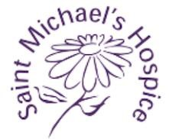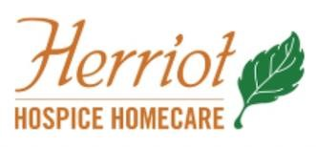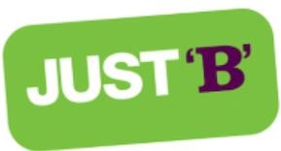

**Key tasks:**

* Inputting information into databases/spreadsheets

* Maintain personnel filing system ensuring that all in-coming / out-going correspondence is scanned and saved to the appropriate systems.

* Support the Safer Recruitment processes including requesting and chasing references and DBS checks.

* To assist with the onboarding process for staff and volunteers as requested.

* Other admin tasks as required

Volunteer HR Services Admin Support – Role Description Page 1

29.01.25

**Key skills/attributes required:**

* Good computer skills including a basic knowledge of Excel, Word and Outlook.

* Ability to follow processes and work on repeat tasks

* Accurate and methodical

* Understanding of and adherence to highest levels of confidentiality

* Positive, upbeat and passionate about the work of Saint Michael’s Hospice
* A previous knowledge/experience of working in HR would be preferred but not essential.

**Training requirements:**

1. All volunteers undergo general induction training

1. Any additional training will be provided as required



Volunteer HR Services Admin Support – Role Description Page 2

29.01.25