Application Form
Application From

Job name/Volunteer role:

Job / Volunteer Reference Number:
GE

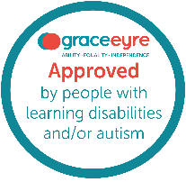
Your Personal Details

 | Name:
 | Address:
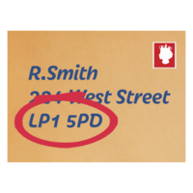 | Postcode:
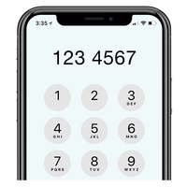 | Home phone number:  Mobile phone number:
 | Email address:
 | National Insurance number:
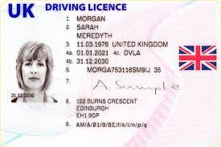 | Driving Licence: ☐ Yes ☐ No  If yes: ☐ Car or ☐ Motorbike  Do you have a D1 Category (where you can drive over a 7.5-tonne vehicle) on your Driving Licence?  ☐ Yes ☐ No
 | How did you hear about this job?
Work / Voluntary Experience:

 | What work/volunteering are you doing now?  What work/volunteering have you done?
Previous Jobs or Volunteering or other work:

 | Previous Job/Volunteering/Other Work:  Company Name:  Dates:
Previous Job/Volunteering/Other Work:

Company Name:

Dates:

Previous Job/Volunteering/Other Work:

Company Name:

Dates:

Your experience, qualifications and skills for the role

 | Why would you be good at this role?
 | What is your previous experience (give examples)?
 | What knowledge do you have (please give examples)?
 | What skills do you have (give examples)?
 | Anything else?
You education, qualifications and training for the Role

 | What Education, Qualifications or certificates do you have (relevant to role)?
 | What training have you had (relevant to role)?
 | Anything else?
Work Availability (please tick)

 |  | Mon | Tues | Wed | Thurs | Fri
 | Morning
 | Afternoon
 | What is your notice period for where you work now?
Other Information
     | Do you have a disability?* ☐ Yes ☐ No ☐ Prefer not to say  If yes, then tell us if there are any things we need to put in place for you to do a recruitment activity:  What type of recruitment activity would you like?  ☐ Online interview  ☐ In person interview  ☐ Interview with support staff or family member  ☐ Task or activity to complete  ☐ Trial Shift  Other things you might want:  ☐ Interview Questions in advance  ☐ Instructions for task or activity given in advance  ☐ Trial shift information given in advance  ☐ One-page profiles of team that will be recruiting you  Please note that if you have your skills and ability assessed by a task or trial shift, then you will still need to have an informal interview with the recruiting team.    *If you have a disability and meet all the essential minimum criteria on the job specification, we will offer you an interview. If you need support please let us know, by emailing: recruitment@grace-eyre.org
 | Do you have a Support Worker? ☐ Yes ☐ No  If you are happy for us to contact them, please tell us their:  Name:  Address:  Telephone number:  Can we ask you Support Worker about your skills?  ☐ Yes ☐ No
 | Do you know anyone who works, volunteers or is a trustee at Grace Eyre?  ☐ Yes ☐ No  If yes, what is their name and how do you know them?  Name:  How I know them:
 | In the last three years have you had any disciplinary action?  ☐ Yes ☐ No  If ‘yes’, please tell us about this:
 | Do you have any criminal convictions or cautions?*  ☐ Yes ☐ No  If ‘yes’, please tell us about this:  * This should include any spent convictions under Section 4 (2) of the Rehabilitation of Offenders Act 1974
 | Have you even been stopped from working with vulnerable adults?  ☐ Yes ☐ No  If ‘yes’, please tell us about this:
 | Do you have the right to work in the United Kingdom?  ☐ Yes ☐ No
 | Are you fully vaccinated against COVID-19?  ☐ Yes ☐ No  Please note, we require all new staff to have had 2 vaccinations.
 | Are you happy to follow all Grace Eyre’s COVID Guidelines when at work?  ☐ Yes ☐ No
References
 | Please give us the names, addresses and phone numbers of 2 people who can tell us about you. One of them must be your current or last employer, or if you haven’t been employed before, a personal, or college reference. We will contact them.
First Contact
 | Name:
 | Job Title:
 | Company:
 | Address:
 | Phone Number:
 | Email Address:
Second Contact
 | Name:
 | Job Title:
 | Company:
 | Address:
 | Phone Number:
 | Email Address:
Declaration
 | Please read the statement below and sign the form only if you agree with it.  - Everything I have written in this form is true.  - I understand that if anything I have written is not true, you won’t offer me the job/volunteer role.  - If you find out later that something I said is untrue, I won’t be offered the job/volunteer role or I may be dismissed.  Please sign here:  Date:
 | Please return to Grace Eyre by post, email or by hand:  Address: Grace Eyre, 36 Montefiore Road, Hove, BN3 6EP  Email: recruitment@grace-eyre.org

